- Write a program to filter a list of names. Use textbox, and ul. On typing the letters in the textbox the list should be filtered.
Coding:
<!DOCTYPE html>
<html lang="en">
<head>
<meta charset="UTF-8">
<meta name="viewport" content="width=device-width, initial-scale=1.0">
<title>Document</title>
</head>
<body>
<ul id="ul1">

</ul>

<input type="text">

<script>
let list = ["IFB","Whirlpool","Samsung"];
let input = document.querySelector("input");
let ul1=document.getElementById("ul1");
list.forEach((element) => {
let li = document.createElement("li");
ul1.appendChild(li).textContent = element;
});

input.addEventListener("input", function(){
let inp = input.value;

ul1.innerHTML = "";
for(let i= 0; i<list.length;i++){
if(inp.toLowerCase() === list[i].toLowerCase()){
let li = document.createElement("li");
ul1.appendChild(li).textContent = list[i];
}
}

})
</script>
</body>
</html>

Output:
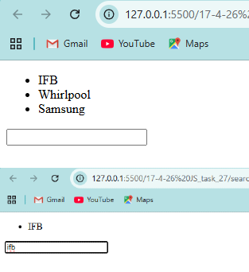

- Display a list of cards containing movie name and image using javascript.
Coding:
<!DOCTYPE html>
<html lang="en">
<head>
<meta charset="UTF-8">
<meta name="viewport" content="width=device-width, initial-scale=1.0">
<title>Anils theatre</title>
<style>
body{
display: flex;
flex-direction: column;
align-items: center;
justify-content: center;
background-color: black;
font-family: Arial, Helvetica, sans-serif;
}
ul{
display: flex;
flex-wrap: wrap;
}
li {

border-radius: 20px;
background-color: rgb(204, 198, 20);
display: flex;
flex-wrap: wrap;
flex-direction: column;
align-items: center;
justify-content: center;
transition: transform;
transition-duration: 0.8s;
/* transition-delay: 0.3s; */
}
li:hover{
transform: scale(1.1) translateY(-10px);
box-shadow: 0 0 20px rgb(198, 196, 196);
}
div {
margin: 0;
padding: 50px;
width: 60vw;
display: flex;
flex-direction: column;
align-items: center;
justify-content: center;
background-color: rgba(255, 255, 255, 0.092);
box-shadow: 0 0 100px rgb(198, 196, 196);
}

p {
margin-top: 10px;
margin-bottom: 10px;
}
h1{
font-size: 50px;
color:azure;
}
img{
height:250px;
width: 170px;
border-top-left-radius: 18px;
border-top-right-radius: 18px;
}
</style>
</head>

<body>
<div id="">

<h1><img src="assests/pngaaa.com-175448.png" style="height:60px; width:60px"> Anils Theatre</h1>
<ul id="movielist"></ul>

</div>
<script>
let ul = document.getElementById("movielist");
ul.style.listStyleType = "none";
ul.style.display = "flex";
ul.style.gap = "50px";
ul.style.textAlign = "center";
ul.style.fontSize = "20px";
let moviedetails = ["Jana Nayagan","GOAT","Leo","Varisu","Beast","Master","Bigil","Sarkar","Mersal"," Bairavaa","Theri","Puli","Kaththi","Jilla","Thalaivaa"];
let images = [];

for(let i=0; i<moviedetails.length;i++){
let li = document.createElement("li");

let p = document.createElement("p");
let img = document.createElement("img");
img.src = `assests/movie${i}.jpeg`;
li.appendChild(img);

li.appendChild(p).textContent = moviedetails[i];
ul.appendChild(li);
}

</script>
</body>

</html>

Output:
